PRIMEHR SYSTEM
Administrator User Manual
Schools Division Office I Pangasinan

Table of Contents
1. System Login
2. Document Types (201 Files)
3. Leave Applications
4. Approved Leave Reports
5. Leave Balances
6. Leave Ledger
7. Leave Transactions
8. Office / Unit OPCRF
9. Employee IPCRF
10. Offices / Units
11. Profile Management

Step 1: System Login Page
This page allows authorized users to securely access the PRIMEHR system using their DepEd email and password.
Important Note: Ensure all entered information is accurate before saving or submitting records.
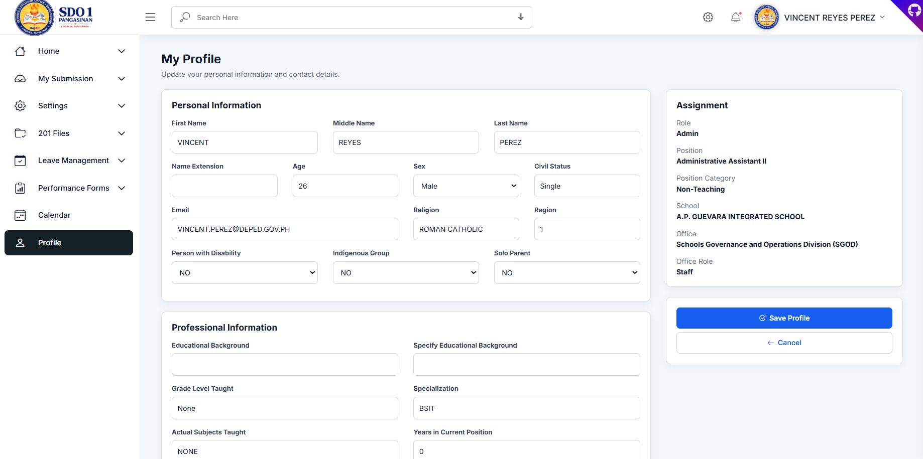
Figure 1. System Login Page
- Navigate using the left sidebar menu.
Review all fields before saving.
Use search and filters to quickly locate records.

Step 2: Document Types (201 Files)
Manage and configure required employee 201 document types used for submissions and validation.
Important Note: Ensure all entered information is accurate before saving or submitting records.
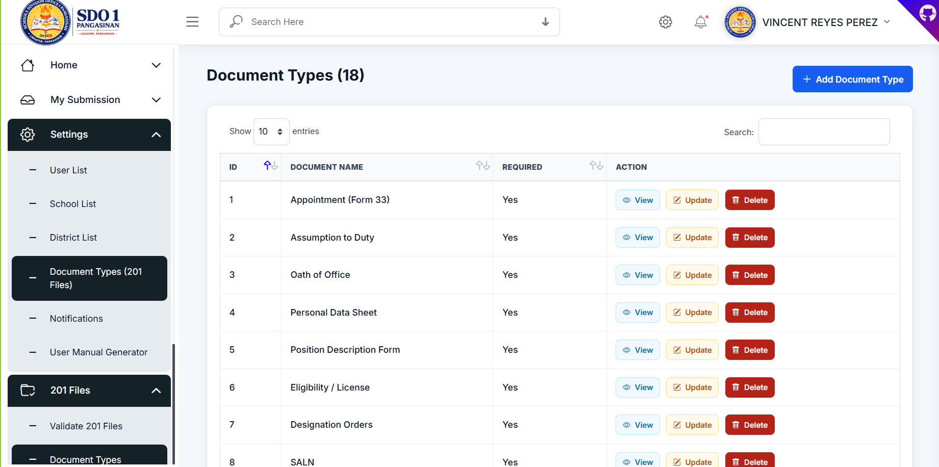
Figure 2. Document Types (201 Files)
- Navigate using the left sidebar menu.
Review all fields before saving.
Use search and filters to quickly locate records.

Step 3: Leave Applications
Review employee leave applications and approve or reject requests with remarks.
Important Note: Ensure all entered information is accurate before saving or submitting records.
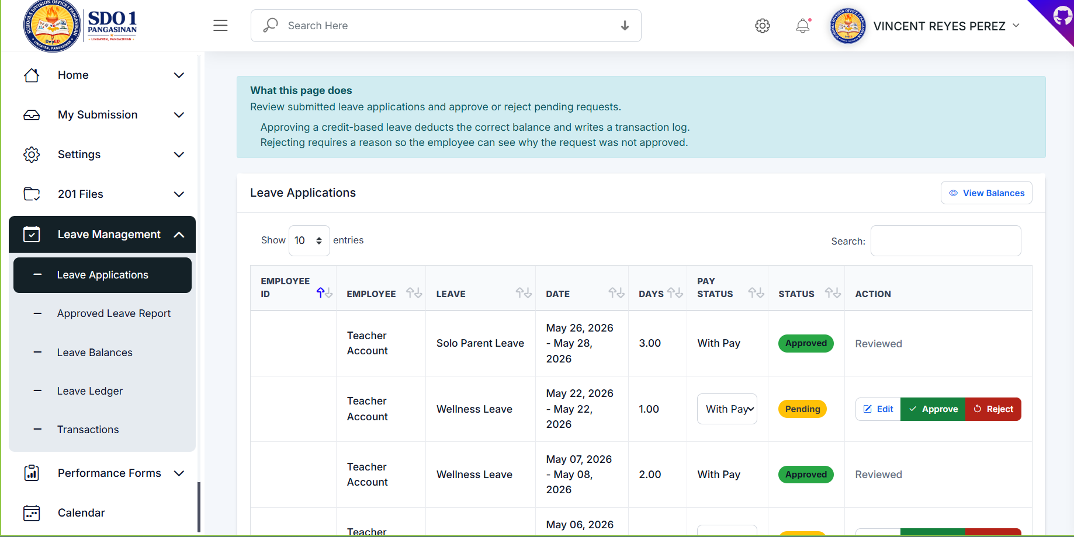
Figure 3. Leave Applications
- Navigate using the left sidebar menu.
Review all fields before saving.
Use search and filters to quickly locate records.

Step 4: Approved Leave Report
View approved leave requests and export reports in CSV or PDF format.
Important Note: Ensure all entered information is accurate before saving or submitting records.
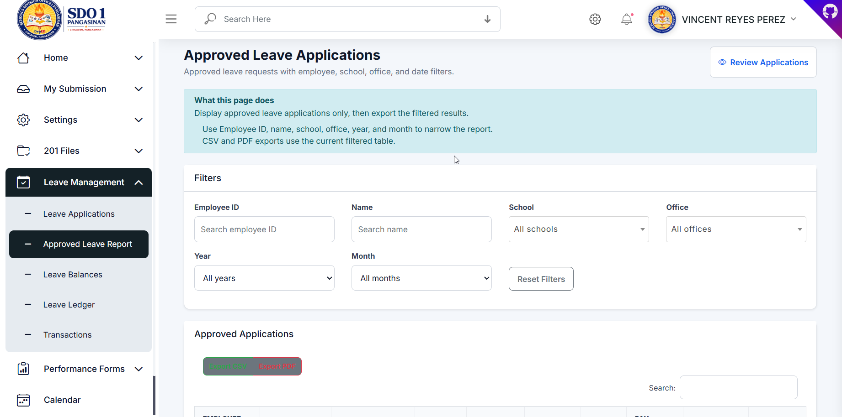
Figure 4. Approved Leave Report
- Navigate using the left sidebar menu.
Review all fields before saving.
Use search and filters to quickly locate records.

Step 5: Leave Balances
Manage employee leave credits and perform manual balance adjustments.
Important Note: Ensure all entered information is accurate before saving or submitting records.
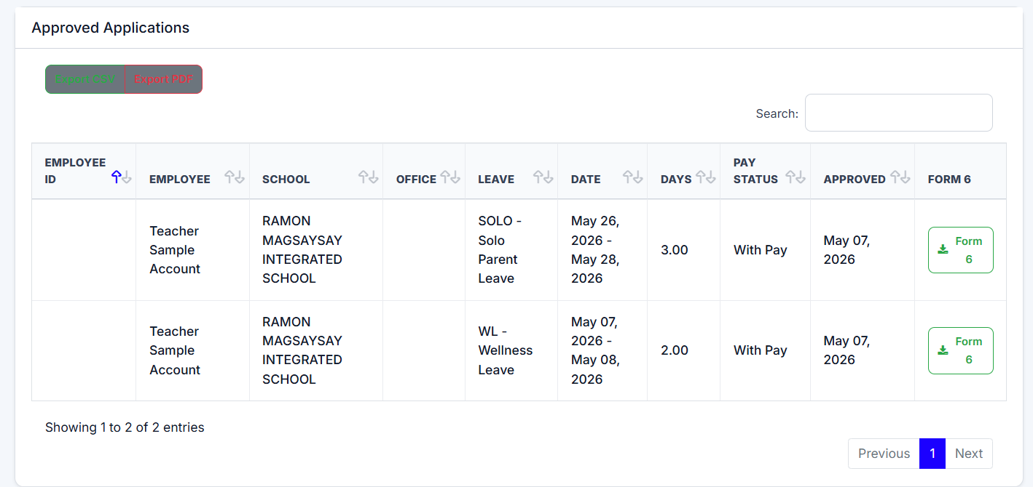
Figure 5. Leave Balances
- Navigate using the left sidebar menu.
Review all fields before saving.
Use search and filters to quickly locate records.

Step 6: Leave Ledger
Monitor employee leave history, earned credits, used credits, and balances.
Important Note: Ensure all entered information is accurate before saving or submitting records.
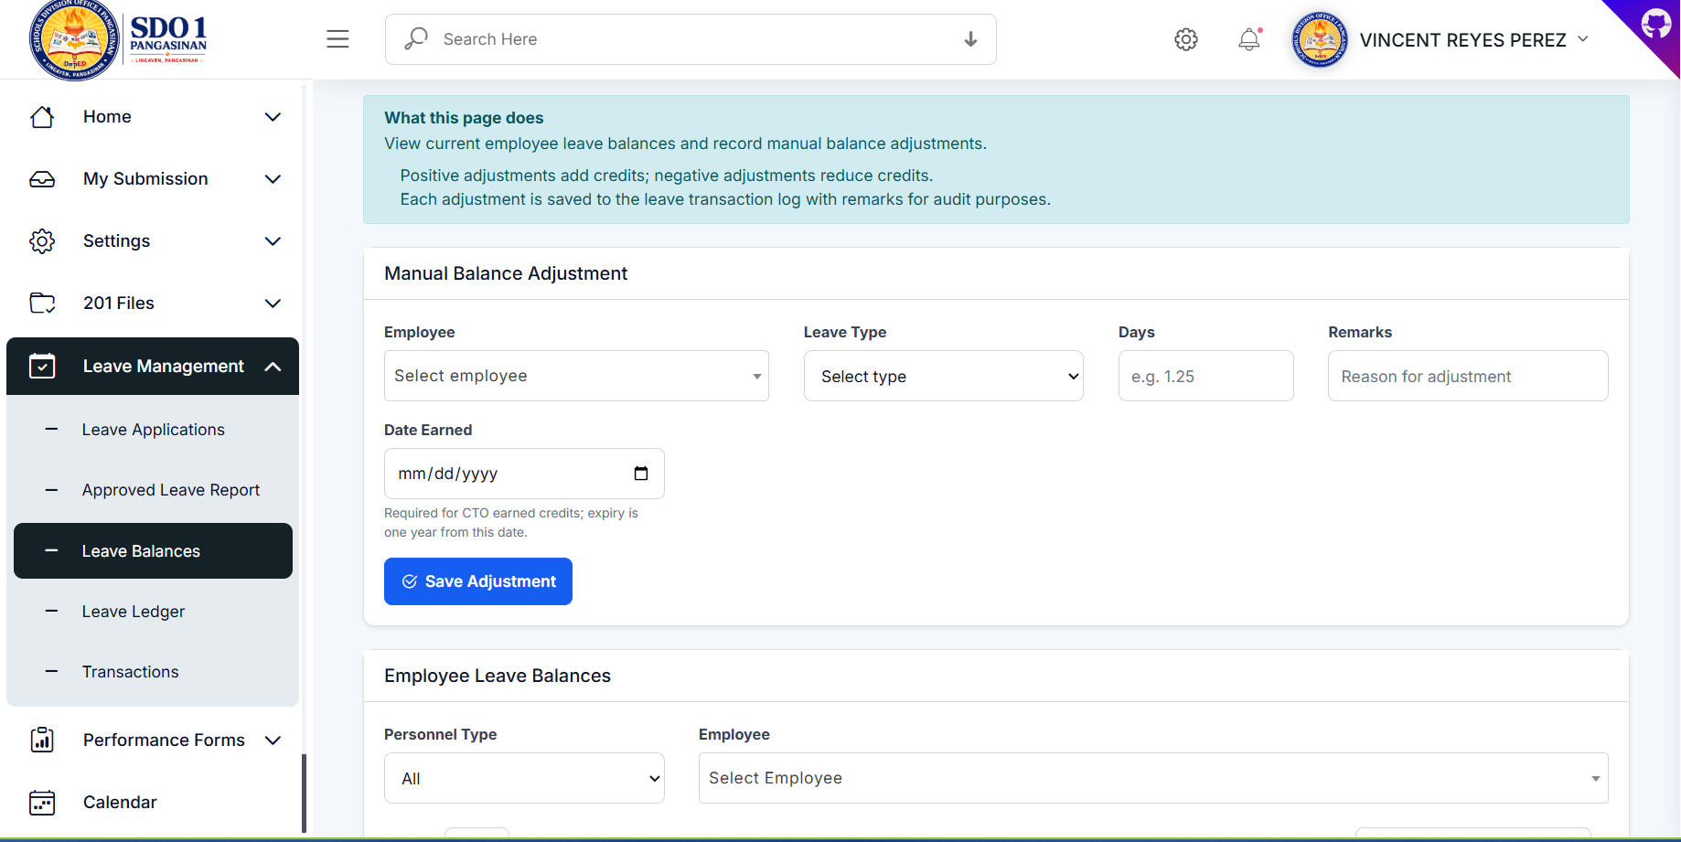
Figure 6. Leave Ledger
- Navigate using the left sidebar menu.
Review all fields before saving.
Use search and filters to quickly locate records.

Step 7: Leave Transactions
Track all leave-related transactions including adjustments and deductions.
Important Note: Ensure all entered information is accurate before saving or submitting records.
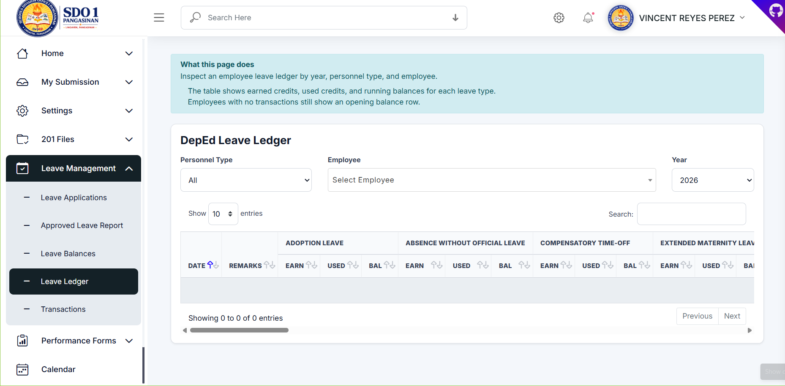
Figure 7. Leave Transactions
- Navigate using the left sidebar menu.
Review all fields before saving.
Use search and filters to quickly locate records.

Step 8: Office / Unit OPCRF
Manage office-level OPCRF submissions and approvals.
Important Note: Ensure all entered information is accurate before saving or submitting records.
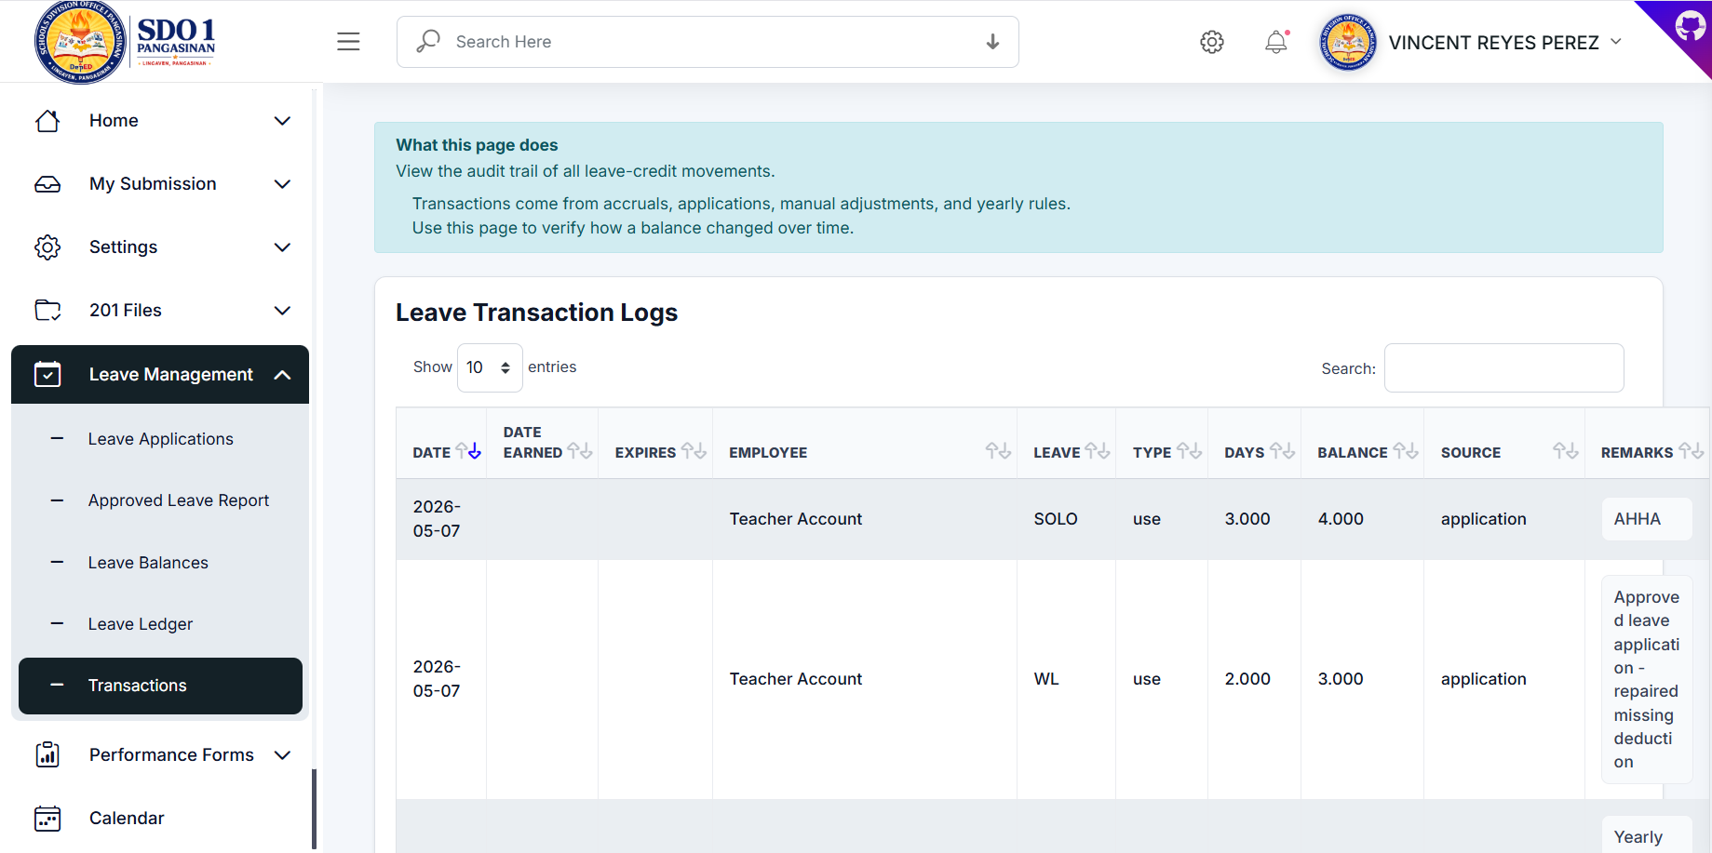
Figure 8. Office / Unit OPCRF
- Navigate using the left sidebar menu.
Review all fields before saving.
Use search and filters to quickly locate records.

Step 9: Add Office / Unit OPCRF
Create a new OPCRF submission by uploading PDF and Excel files.
Important Note: Ensure all entered information is accurate before saving or submitting records.
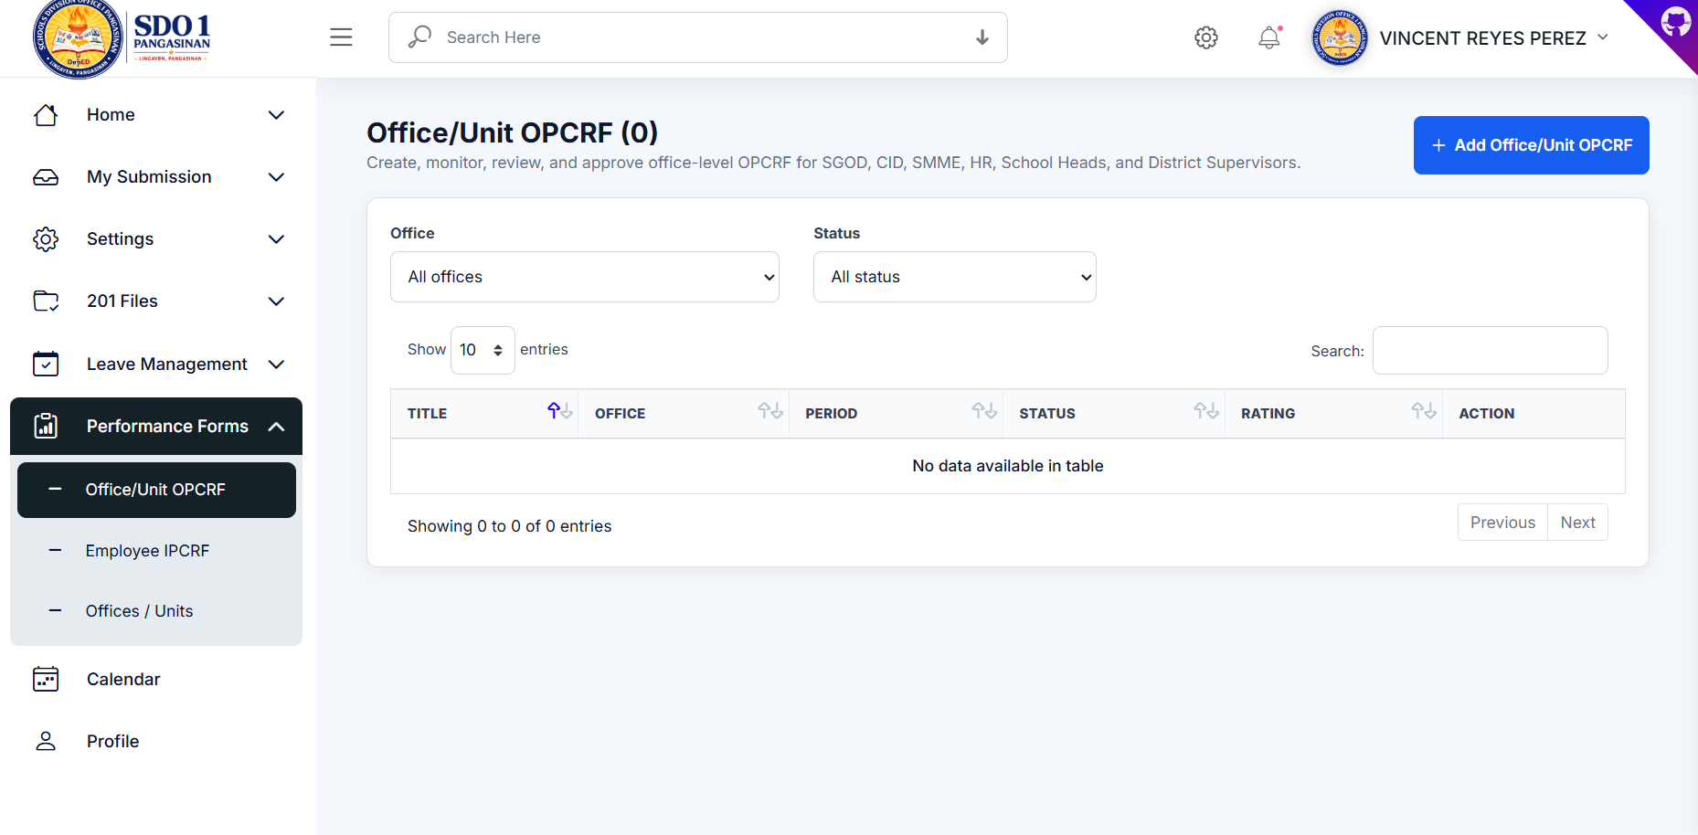
Figure 9. Add Office / Unit OPCRF
- Navigate using the left sidebar menu.
Review all fields before saving.
Use search and filters to quickly locate records.

Step 10: Employee IPCRF
Monitor and review submitted employee IPCRF forms.
Important Note: Ensure all entered information is accurate before saving or submitting records.
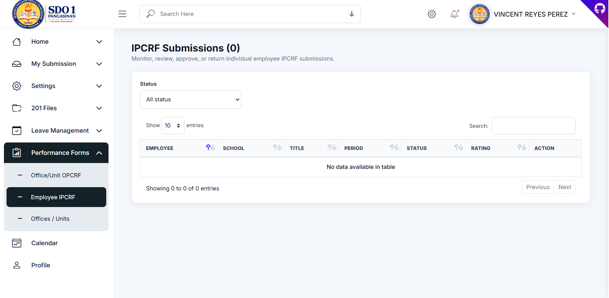
Figure 10. Employee IPCRF
- Navigate using the left sidebar menu.
Review all fields before saving.
Use search and filters to quickly locate records.

Step 11: Offices / Units
Manage office and unit assignments, signatories, and OPCRF submitters.
Important Note: Ensure all entered information is accurate before saving or submitting records.
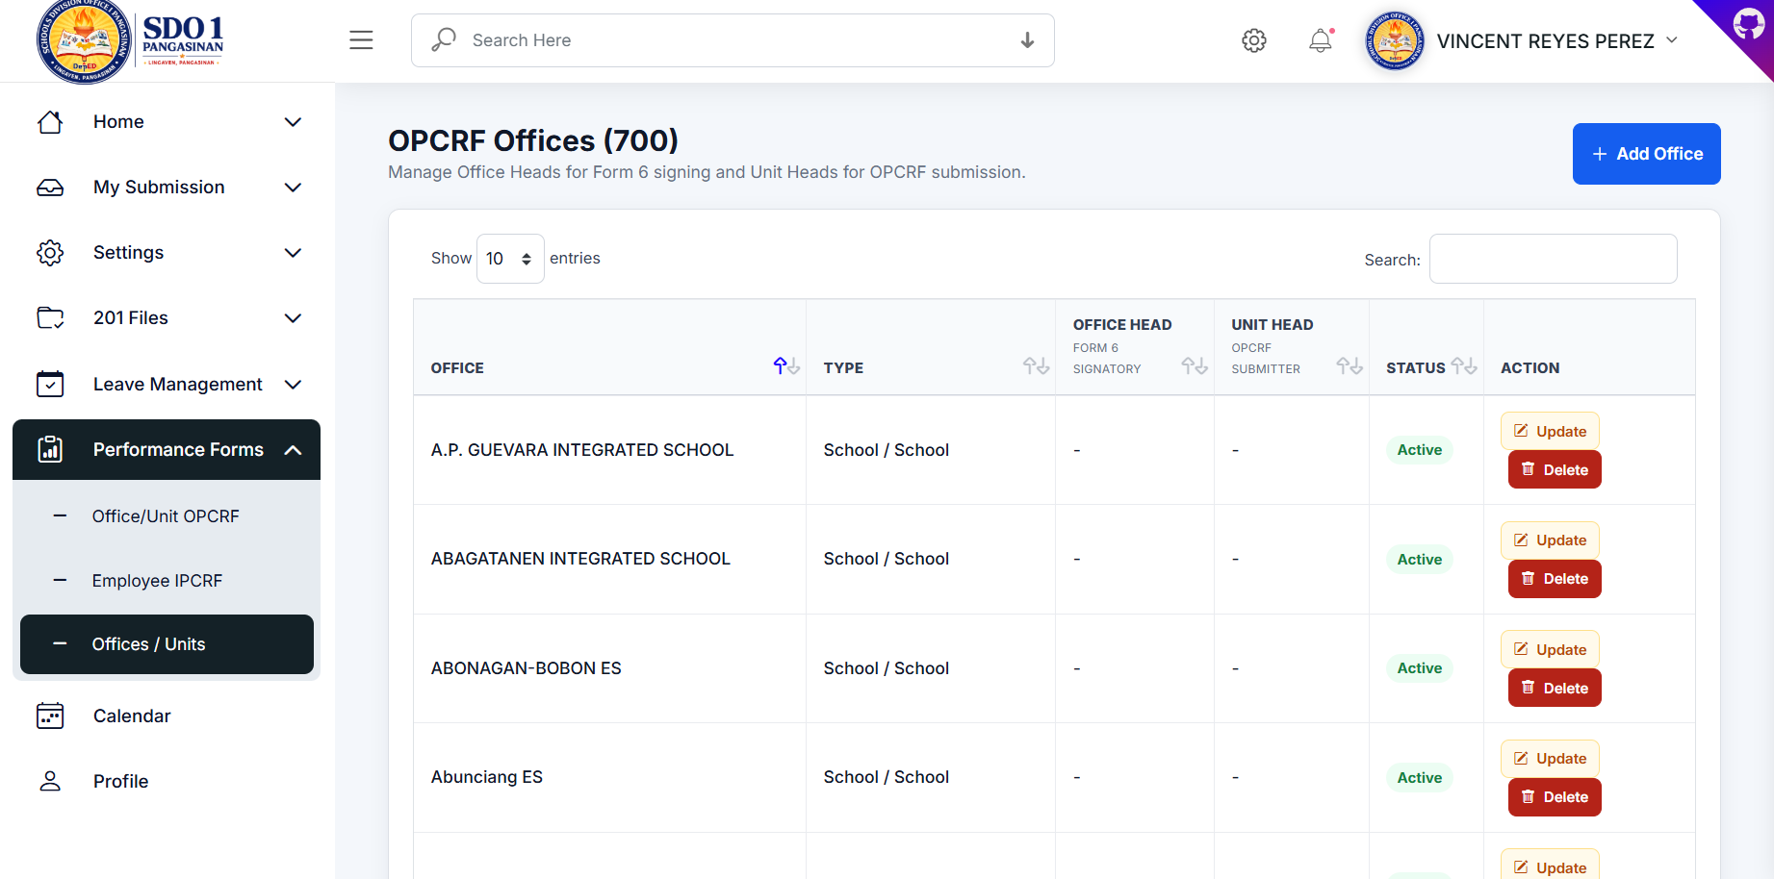
Figure 11. Offices / Units
- Navigate using the left sidebar menu.
Review all fields before saving.
Use search and filters to quickly locate records.

Step 12: Add Office Modal
Configure office information, office heads, unit heads, and linked schools.
Important Note: Ensure all entered information is accurate before saving or submitting records.
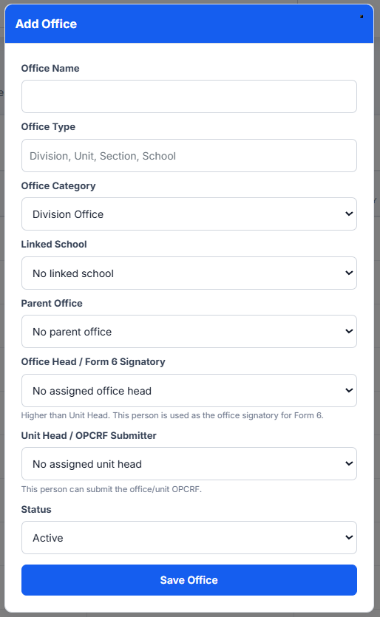
Figure 12. Add Office Modal
- Navigate using the left sidebar menu.
Review all fields before saving.
Use search and filters to quickly locate records.

Step 13: User Profile
Update personal and professional profile information within the system.
Important Note: Ensure all entered information is accurate before saving or submitting records.
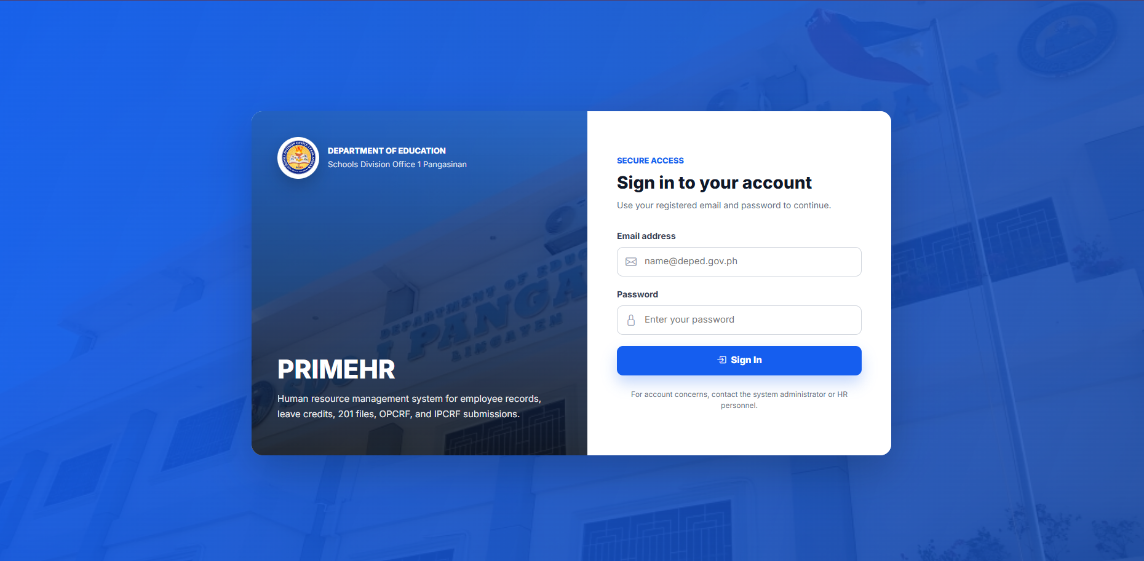
Figure 13. User Profile
- Navigate using the left sidebar menu.
Review all fields before saving.
Use search and filters to quickly locate records.

